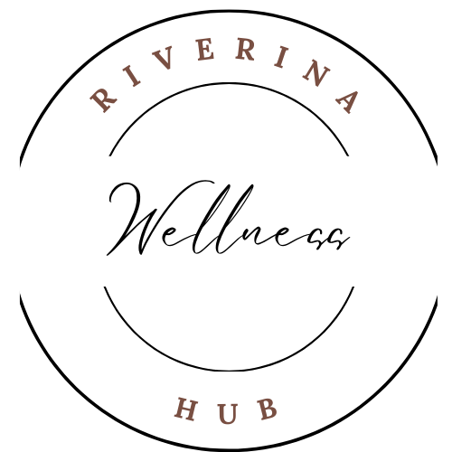

Community Member - New Profile

**(Online practitioner database entry form)**

* **Full Business name:**
* **Owner name and phone number/ or approved representative** (** Note this is for admin purposes not for online directory for public)

* **1 paragraph (3/4 sentences) introduction about who you are and what you do:**

* **Overview of modalities trained in: (Bullet point form)**

**\***

**\***

**\***

**\***

* **How you work? *short explanation of method used (table/laying down/floor, seated, hands on/hands off etc)***

* **What you offer: Specific advertised services (sessions/cost) *add any specific programs**

* **How can people contact you?**

**Email:**

**Phone:**

**Socials**

**Other:**

***Thankyou for joining the online community & database. The vision is to link the right people together to support our greater community to access more holistic wellness services.***

Em x

**(*Note: If you are interested in learning more about the paid membership option ($120p.a. payment plans available) please get in touch.**

**In the paid membership you receive support in advertising. This includes an interview (video) & a write up to use on all platforms, onsite advertising space for business cards, flyers etc, option to offer consults in person on site at pop ups in private area, endorsement (formal background check and reviews), and to be a part of the referal program.**